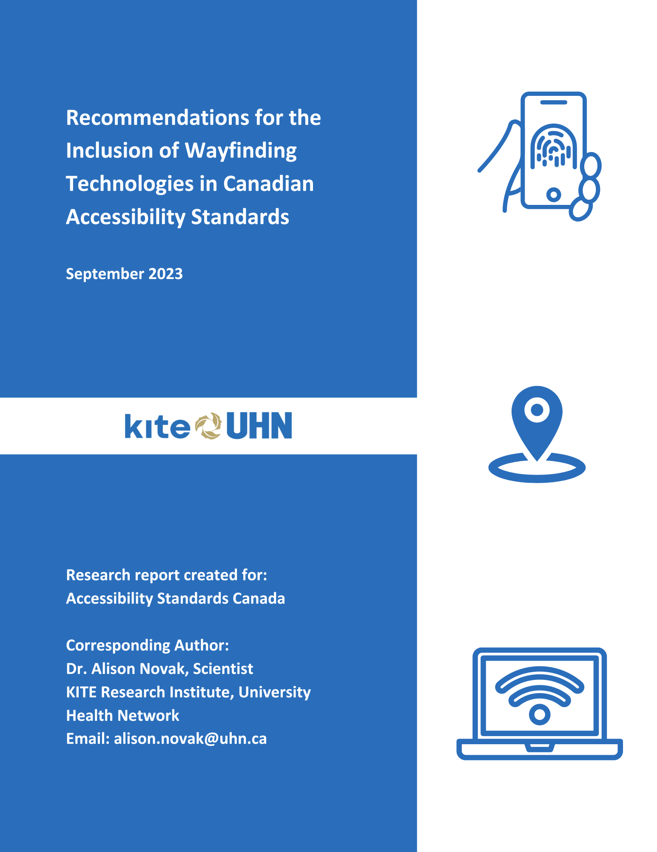
Executive Summary
Wayfinding through unfamiliar environments may be uniquely challenging for people with disabilities, impacting one’s ability to move safely and confidently. The emergence of wayfinding technologies offers an important solution to supporting safe and accessible navigation through environments for people with disabilities. Example of wayfinding technologies include smartphone apps, digital maps, or features of assistive devices that collect and convey information to guide the user through complex spaces. While wayfinding technologies are becoming increasingly more common in availability and use, the consideration of these tools in accessibility standards may be limited. A better understanding of how Canadians with disabilities use wayfinding technology, and barriers and facilitators to the use of various wayfinding technologies, will allow us to generate recommendations for inclusion of wayfinding technology in future standards.

The overall project objective was achieved using a multi-faceted approach. We (1) carried out an environmental scan to identify international and Canadian standards that include (any) aspects of wayfinding technology, (2) conducted a national survey to better understand facilitators and barriers to the use of wayfinding technologies by individuals with disabilities, and (3) facilitated a co-design workshop with members from Canadian National Institute for the Blind to understand wayfinding technology use and how to best include within accessibility standards. In collaboration with our project partner organizations, we then (4) developed a set of recommendations for the inclusion of wayfinding technologies within accessibility standards in Canada based on findings from (2) and (3).

This report provides several key outputs to facilitate the development of wayfinding technology standards. First, we provide a resource of existing accessibility legislation, codes, standards, guidelines that regulate and guide wayfinding technology. Based on the research findings of a national survey and co-design workshops, we have identified key areas to improve the accessibility, standardization, and usability of wayfinding technology. We provide recommendations within each area to consider within an accessibility standard. Areas are subdivided into those that:

  - Support decision-making processes for individuals;
  - Support the organization and communication of information;
  - Support use in real-world public settings; and
  - Provide broader support for the use and implementation

Wayfinding technology can play a powerful role in serving a wide range of users with an even wider range of needs. Findings from this work will assist in the development of future wayfinding standards that intend to include standardization of wayfinding technologies. Through improved standardization we can work to remove current barriers to accessibility, and prevent new barriers as they relate to wayfinding within public spaces.
Authorship and Contributions

The Research Team
Alison C. Novak, Scientist, KITE Research Institute-University Health Network; Assistant Professor, University of Toronto

Jennifer Campos, Senior Scientist & Associate Director, KITE Research Institute-University Health Network; Associate Professor, University of Toronto; Associate Scientific Director, AGE-WELL NCE

Tilak Dutta, Scientist, KITE Research Institute-University Health Network; Assistant Professor, University of Toronto

Thianna Edwards, Research Analyst, KITE Research Institute-University Health Network

David Houston, Research Associate, KITE Research Institute-University Health Network

Rianna Khaki, Research Analyst, KITE Research Institute-University Health Network

Esther Leung, MScOT Research Student, University of Toronto

Iris C. Levine, Scientific Associate, KITE Research Institute-University Health Network

Ealu Li, MScOT Research Student, University of Toronto

Project Partners
Josh Vander Vies, President, Canadian Disability Foundation

Mahadeo Sukhai, Vice-President Research and International Affairs & Chief Accessibility Officer, Canadian National Institute for the Blind (CNIB); Assistant Professor (Adjunct), Queens Health Sciences, Queens University

Renu Minhas, Research Coordinator, DeafBlind Ontario Services

Karen Keyes, Chief Operating Officer, DeafBlind Ontario Services

Hans Uli Egger, RHFAC Accessibility Certification Specialist and Adjudicator, Rick Hansen Foundation

Colette Parras, Architect (NL) M.Arch, BFA (Hons.) SEGD member, RHFAC Technical Subcommittee

Acknowledgements
The authors wish to acknowledge funding from Accessibility Standards Canada Grants and Contributions program for this work.

Table of Contents

List of Figures 8
List of Tables 9
1. Introduction 10
2. Project Objectives and Approach 16
3. Environmental Scan of Current Accessibility Legislation, Standards, Codes, and Guidelines Including Aspects of Wayfinding Technology 17
3.1 Environmental scan, methods 17
3.2 Environmental scan, summary of results 18
4. Canadian National Survey of Barriers and Facilitators to Wayfinding Technology Use by People With Disabilities 20
4.1 Survey participant demographics 20
4.2 Overall engagement with wayfinding technology 21
4.3 Results: Facilitators related to use of wayfinding technology 22
4.4 Results: Barriers related to the use of wayfinding technology 27
5. Co-Designing Wayfinding Technology Standards: Identifying Key Themes for Wayfinding Technology for People With Visual Impairment/Visual Disabilities 33
5.1 Co-design workshop methods 33
5.2 Summary of co-design workshop findings 34
6. Moving Forward: Considerations for the Accessibility, Usability, and Standardization of Wayfinding Technology for People With Disabilities 40
6.1 Support for decision making 40
6.2 Organization and communication of information 41
6.3 Supporting use in real-world public spaces 42
6.4 Broader support of wayfinding technology use and implementation 44
7. Glossary of Terms 46
8. References 48
Appendix A – Summary of environmental scan results of wayfinding technologies included in accessibility legislation, codes, standards, guidelines 52

List of Figures

Figure 1. Example image of a mobile application, showing a person using a mobile mapping application to preview a route 9
Figure 2. Example image of a web application; the webpage is providing wayfinding information for Canadian airport 9
Figure 3. Example image of a wearable device. (Left) man wearing a pair of augmented reality sunglasses; (Right) example output the user may see through the glasses 10
Figure 4. Example of a smart assistive device, a white cane with sensors embedded in the tip and sensors within the handle 10
Figure 5. Example image of a tactile public interface (e.g., Tactile map) 11
Figure 6. Example image of a digital public interface (e.g. digital map) 11
Figure 7. Number of survey participants who indicated they use/have used various categories of technology to assist with wayfinding in public spaces 18
Figure 8. Main facilitators of use that are common to personal and publicly available wayfinding technology 19
Figure 9. Facilitators Specific to Personal Wayfinding Technology (mobile apps, websites, wearables, and smart assistive devices) 21
Figure 10. Facilitators Specific to Public Wayfinding Technology (digital and tactile public interfaces) 22
Figure 11. Barriers to wayfinding technology use that are common across personal and public technologies 24
Figure 12. Barriers specific to personal wayfinding technology (i.e., mobile apps, websites, wearables, and smart assistive devices) 25
Figure 13. Barriers specific to public wayfinding technology (i.e., digital and tactile public interfaces) 27

List of Tables

Table 1. Survey participant demographics (n = 282) 17
Table 2. Demographic characteristics for participants reporting barriers to wayfinding technology use (n = 213) 23
Table 3. Summary of themes related to use of wayfinding technology, discussed barriers and facilitators to use of technology, and recommendations discussed by participants for inclusion in accessibility standards 29
Table A-1. Detailed summary of international accessibility legislation, standards and guidelines included in the environmental scan that contain aspects of wayfinding technology.
.................45
Table A-2. Detailed summary of national accessibility legislation, standards and guidelines included in the environmental scan that contain aspects of wayfinding technology.
.................48
Table A-3. Detailed summary of provincial accessibility legislation, standards and guidelines included in the environmental scan that contain aspects of wayfinding technology.
................ 50
Table A-4. Detailed summary of municipal and community level accessibility legislation, standards and guidelines included in the environmental scan that contain aspects of wayfinding technology.
...................................................................................................... 52

Introduction
One in five Canadians aged 15 years and over, or approximately 6.2 million individuals, live with one or more disabilities (Morris, Fawcett, Brisebois, & Hughes, 2018). The most common types of disabilities are those related to pain, flexibility, mobility, and mental health, followed by those related to vision, hearing, dexterity, learning, and memory (Morris, Fawcett, Brisebois, & Hughes, 2018). Among this population of individuals with disabilities, 29% have only one disability type; 38% have two or three disability types, and 33% have four or more disability types (Morris, Fawcett, Brisebois, & Hughes, 2018). In addition, the prevalence of disability increases with age - approximately 13% of those aged 15 to 24 years identify as having at least one type of disability, which increases up to 47% for those aged 75 years and over. As our population ages, the prevalence of disability in Canadians is expected to rise (Morris, Fawcett, Brisebois, & Hughes, 2018).

Wayfinding through unfamiliar environments may be uniquely challenging for people with disabilities, impacting one’s ability to move safely and confidently (Centers for Disease Control and Prevention, National Center on Birth Defects and Developmental Disabilities, 2020). Wayfinding activities include spatial orientation, navigation, and destination identification. As defined by the Canadian Standards Association (CSA Group, 2018), wayfinding refers to “a spatial problem-solving process based upon consistent use and organization of sensory cues in the environment that individuals use to understand where their location is, know where their desired destination is, and know how to get to that destination from their present location”. Supportive environments/wayfinding systems for people with disabilities are important as they have been associated with improved employment outcomes and social inclusion (Murdoch, Pey, & Brooks, 2022) – both of which contribute to a higher quality of life and increased independence.

Traditional wayfinding tools are importantly included in current Canadian standards (CSA Group, 2018). Traditional wayfinding elements may be thought of as the physical or architectural features present in the built environment such as lighting, tactile flooring systems, and/or signage. Despite the presence of these elements in our built environment, continued barriers related to aspects of wayfinding are frequently identified by people with disabilities in complex environments, such as within public pedestrian spaces, transportation facilities, and healthcare settings (Lau, et al., 2020). Given the presence of continued barriers that relate to aspects of wayfinding, it is not surprising why future wayfinding-specific standards are currently being developed within Canada.

The Emergence of Technology to Support Wayfinding
The emergence of wayfinding technologies offers an important solution to supporting safe and accessible navigation through environments for people with disabilities. Wayfinding technologies can be operationally defined as systems or innovations that exist beyond traditional architectural elements. Some examples of wayfinding technologies may include the use of smartphones, digital maps, or adaptations of assistive devices and aides that may be used to collect and convey information to assist guidance through complex spaces. In this study, wayfinding technologies and tools have been grouped into 6 categories (Prandi, Barricelli, Mirri, & Fogli, 2023). These include (1) mobile applications, (2) website applications or websites, (3) wearable devices, (4) “Smart” assistive devices or assistive devices with embedded sensor/communication features, (5) digital public interfaces, and (6) tactile public interfaces. Definitions from (Prandi, Barricelli, Mirri, & Fogli, 2023):

- Mobile applications: this type of wayfinding technology includes applications for smartphones, personal digital assistants (PDAs), and special tablets. An example mobile application illustrating a map navigation tool on a smartphone is shown below.

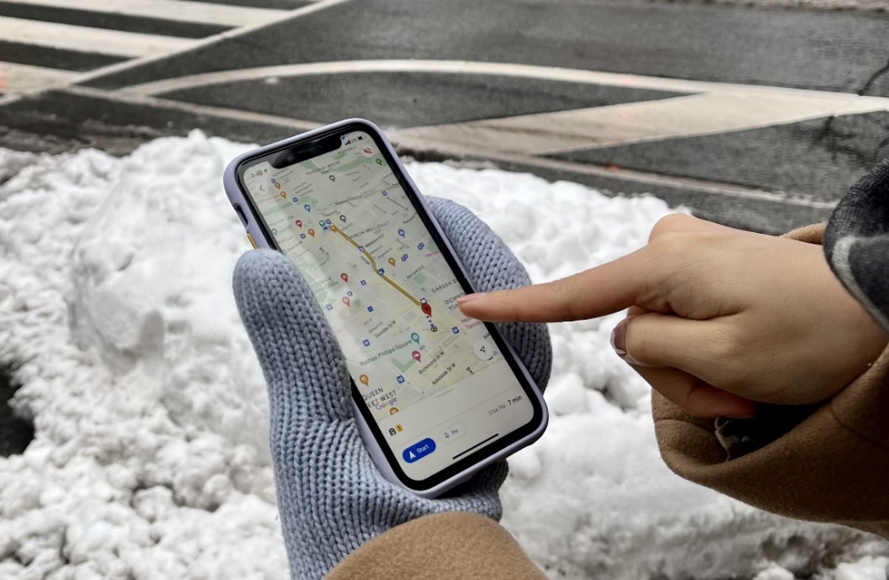

Figure 1. Example image of a mobile application, showing a person using a mobile mapping application to preview a route

- Web applications: this type of wayfinding technology includes applications which are sourced through websites, and are mainly designed to support wayfinding and/or identify accessibility information of places and roads. An example webpage is illustrated below, which provides wayfinding information for a user visiting a Canadian airport

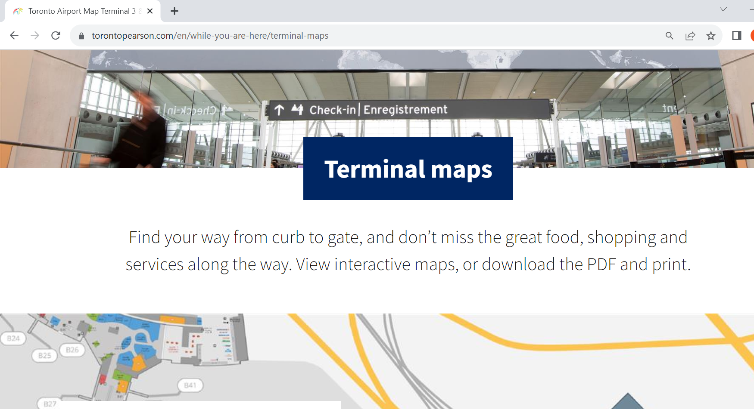

Figure 2. Example image of a web application; the webpage is providing wayfinding information for Canadian airport

- Wearable devices: this type of wayfinding technology include smart glasses, smart watches and other smart objects that the user may wear to obtain real-time information about the environment and instructions for moving inside it. An example wearable device is shown below. Figure 3 shows a wearable pair of glasses while the image on the right provides an example of the display that is shown to the person through the glasses [images from (Montuwy, Cahour, & Dommes, 2019)]

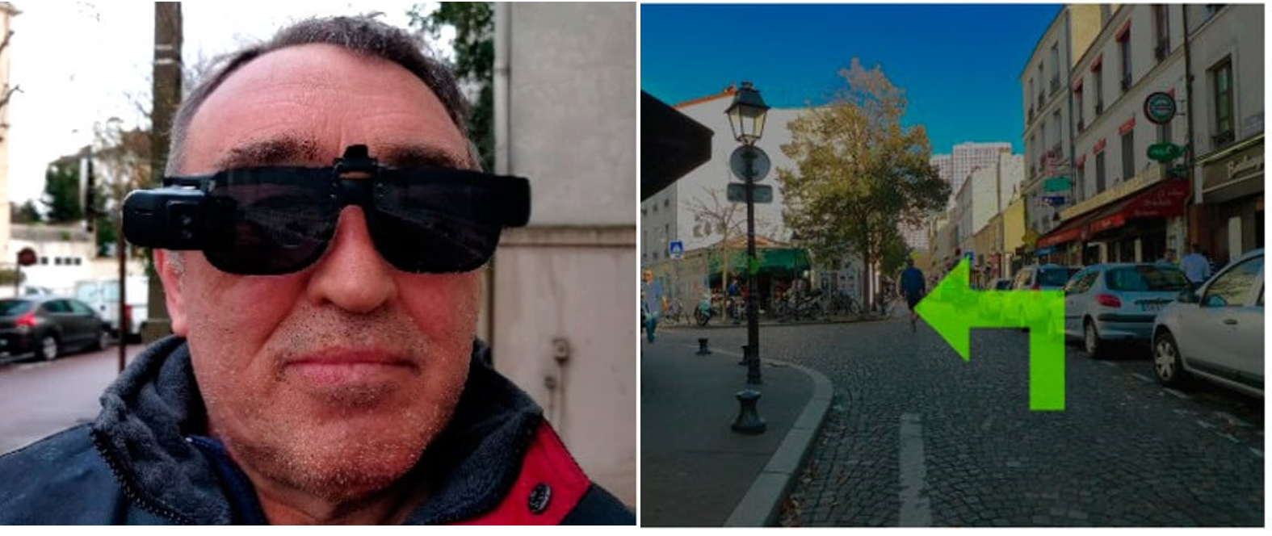
Figure 3. Example image of a wearable device. (Left) man wearing a pair of augmented reality sunglasses; (Right) example output the user may see through the glasses

- Smart devices: this type of wayfinding technology includes physical assistive devices, such as white canes and wheelchairs, which have embedded sensors, actuators, and/or communication features to detect obstacles and assist with routes selection within an environment. An example “smart device” is shown below. The device shown is a white cane embedded with sensors in the tip of the white cane to detect obstacles, and sensors within the handle of the white cane that send sensory feedback to the user [image from (Frizziero, Liverani, Donnici, Papaleo, & Leon-Cardenas, 2021)]

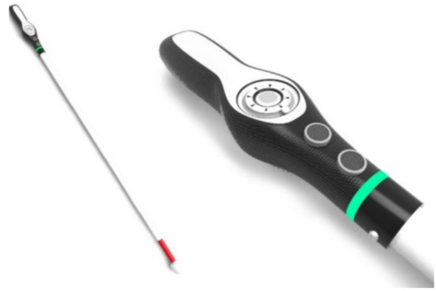

Figure 4. Example of a smart assistive device, a white cane with sensors embedded in the tip and sensors within the handle

- Tactile public interfaces: this type of wayfinding technology includes solutions that provide individuals with accessibility information in public spaces. Tactile interfaces may include maps with raised features or 3-D maps. An example tactile public interface (e.g. tactile map) is shown below [image from (Marcoe, Pateman, & Venhola, 2022)].

Figure 5. Example image of a tactile public interface (e.g., Tactile map)

- Digital public interfaces: this type of wayfinding technology includes solutions that provide individuals with wayfinding information in public spaces. Digital public interfaces may include digital maps or digital kiosks. An example digital public interface (e.g., digital map) is shown below.

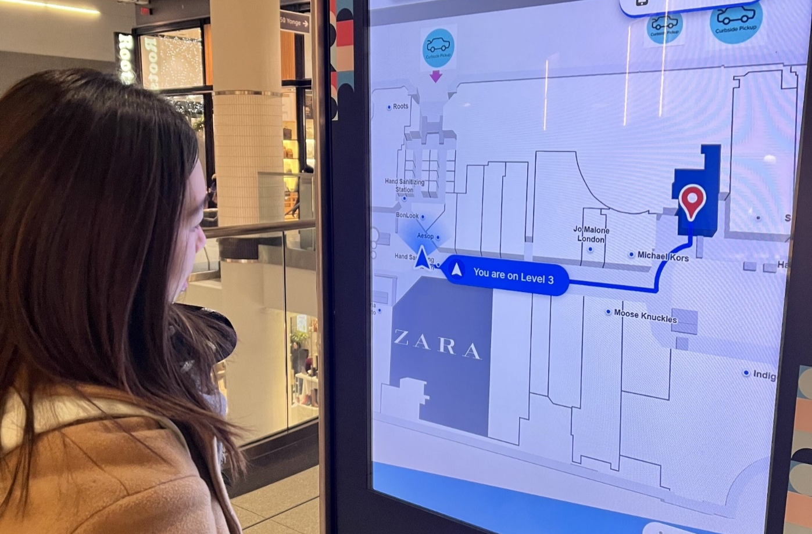

Figure 6. Example image of a digital public interface (e.g. digital map)

For this report, we have categorized the various wayfinding technology types into personalized or public technology.

- Personalized wayfinding technologies: refer to personal devices an individual would need to acquire for their own use, including mobile applications, websites, wearable devices, and smart assistive devices.

- Public wayfinding technologies: refer to technologies located in public areas, which are shared amongst the population. These public technologies include digital and tactile interfaces.

While the proliferation in the availability and use of technology for wayfinding is promising to support accessibility, there are also many barriers to accessing assistive technology that must be considered. Broadly, the lack of awareness and affordability, lack of product support services, inadequate product quality, range and quantity, fragmentation of the assistive technology sector, and sociodemographic barriers have been identified relating to various types of technology use for people with disabilities (World Health Organization (WHO) and the United Nations Children's Fund (UNICEF), 2022). Despite barriers to broad technology access, wayfinding technology tools to assist people with disabilities are continuously being developed and used. Wayfinding technologies may be generalized for many users or uniquely refined to support the specific needs of an individual or a user population (e.g. people with vision loss, people using mobility devices, and people with cognitive disabilities). While this may present as a promising solution for many, several challenges are present. First, the widespread uptake of such technologies by people with disabilities in Canada is currently unknown. The standardization of wayfinding technologies may also be challenging. Technology development is dynamic and fast-paced and the use of wayfinding technology may be individualized rather than broadly implemented by an organization/public space/facility. Because of this, prescriptive standardization of wayfinding technologies may or may not be feasible. Instead, it may be that aspects of wayfinding technologies should be considered for standardization to ensure that the availability and consideration of minimum criteria are included. Research focused on understanding current wayfinding technology available for people with disabilities, including acceptance of use and barriers to use, will allow us to generate a core set of recommendations for inclusion in the development of future wayfinding standards.

Project Objectives and Approach
The goal of this project is to provide a set of recommendations for the standardization of wayfinding technologies. This information is necessary to better inform future wayfinding standards that intend to include standardization of such technologies, remove current barriers to accessibility, and prevent new barriers as they relate to wayfinding within public spaces.
The overall project objective was achieved through three specific aims:
Aim 1: To identify national/international standards that include (any aspects of) wayfinding technology

Aim 2: To understand acceptance of wayfinding technologies, including facilitators and barriers to the use of wayfinding technologies by people with disabilities

Aim 3: To develop a set of recommendations for the inclusion of wayfinding technologies within accessibility standards in Canada

Environmental Scan of Current Accessibility Legislation, Standards, Codes, and Guidelines Including Aspects of Wayfinding Technology
There are an increasing number of accessibility standards and guidelines being employed across Canada and Internationally. Given the many available documents, an environmental scan of international, national, provincial, and municipal-level standards and guidelines was carried out to identify any aspects of wayfinding technology that are currently defined with standards. The results of our environmental scan may serve as a resource for accessibility standards that include (at least some aspect of) wayfinding technology. It should be noted that only publicly available documents (including accessibility legislation, standards, or guidelines) were included in this scan and only those meeting our pre-defined search criteria. This may underrepresent initiatives undertaken by certain municipalities or regions as documents identified may not have met inclusion criteria or were not publicly available. While this environmental scan is not exhaustive of all available documents that may include wayfinding technology, the findings provides an overview of many resources available.

Environmental scan, methods
For Canadian documents, we referred to a recent publication (“A Canadian Roadmap for Canadian Accessibility Standards”) summarizing up-to-date accessibility legislation, and standards, employed across Canada (Lau, et al., 2020). All National level documents that were present in the Lau, et al., 2020 roadmap were included in this environmental scan. The provincial and municipal documents that were included from the roadmap were based on the top 10 most populated cities according to Statistics Canada, including:
- Toronto, Ontario
- Montreal, Quebec
- Calgary, Alberta
- Ottawa, Ontario
- Edmonton, Alberta
- Winnipeg, Manitoba
- Mississauga, Ontario
- Vancouver, British Columbia
- Brampton, Ontario
- Hamilton, Ontario

Searches using Google Search Engine included permutations of search terms within the following categories (English only):
- Topic: “accessibility”, “accessible”
- Document type: “standard”, “guide”, “regulation”, “policy”, “code”, or “guideline”
- Jurisdiction: Name of the country, province/territory/state, name of municipality/community
- Organization type: “transportation/transit”, “park”, “museum, “shopping centre”, “library”, “healthcare/health facility”, “airport”

Relevant international standards and guidelines were found using similar search terms identified above through the Google Search Engine. Any standards relating to wayfinding published by The International Organization for Standardization (ISO) were reviewed in addition to international searches for the following countries: the United States, Europe, Australia, and New Zealand. We chose these specific countries because of their size and/or that they have accessibility legislation in place. Within the United States specifically, we included only the top 10 most populated States:

- California
- Texas
- Florida
- New York
- Pennsylvania
- Illinois
- Ohio
- Georgia
- North Carolina
- Michigan

Environmental scan, summary of results
Based on our search criteria, the environmental scan examined 148 total documents. A detailed summary of the elements of various wayfinding technologies included in current documents can be found in Appendix A, Tables A-1 to A-4. The summary tables are organized according to jurisdiction (International, National, Provincial and Municipal/Local). The final number of documents included under each section is as follows:
- International: 13 documents
- Canadian, National: 7 documents
- Canadian, Provincial: 10 documents
- Canadian, Municipal: 10 documents
The results of our environmental scan may serve as a resource of accessibility standards that include (at least some aspect of) wayfinding technology. As summarized in Tables A-1 to A-4, several of the reviewed documents defined provisions related to the use of at least one element of wayfinding technology. Across all documents, the majority of the elements defined relate to specifications for digital kiosks, audio systems, and/or assistive listening systems. In public building codes, requirements for inclusion of wayfinding technology was generally limited to buildings of assembly occupancy. Not surprising, accessibility standards across jurisdictions provided more in depth requirements related to application and design requirements for various wayfinding technologies than those found in building codes. The largest number of documents described considerations related to digital maps/kiosks, and assistive listening systems. Few documents included descriptions of considerations for mobile applications, websites, and even fewer for smart assistive devices.
Across all documents included in our final sample, several are noteworthy as they provide a comprehensive description of how to best consider standards for various types of wayfinding technology. CAN/CSA-B651.2:22 (Accessible design for self-service interactive devices) is a detailed standard providing design and application requirements for digital public interfaces, beyond the briefer description including in many other documents. ANSI/CTA-2076 (Inclusive, audio-based, network navigation systems for all persons including those who are Blind/Low Vision) provides a detailed, performance-based description of how to best provide accessible audio-based wayfinding navigation systems; the principles described within this standard could be applied to multiple technology types.

Canadian National Survey of Barriers and Facilitators to Wayfinding Technology Use by People With Disabilities
To gain an understanding of the barriers and facilitators of current wayfinding technology use by people with disabilities a national survey was conducted. The survey was disseminated to individuals 18 years and older, residing in Canada and identifying as having lived experience with a disability or health condition affecting their experiences with wayfinding. Survey respondents were asked about their experiences with various wayfinding technology, organized by the previously defined technology categories: (1) mobile applications, (2) website applications or websites, (3) wearable devices, (4) "smart" assistive devices or assistive devices with embedded sensor/communication features, (5) tactile public interfaces, and (6) digital public interfaces.

Survey participant demographics
A total of 282 eligible survey respondents participated. Participant demographics are summarized in Table 1 below. Generally, participants had an average age of 47.9 years. Our participant sample represented a diverse group of people with disabilities, although the primary disabilities represented were those related to mobility/flexibility/dexterity and vision. The majority of participants identified as having one disability type, followed by those having two disability types.
Table 1. Survey participant demographics (n = 282)
Variable of interest | Total participants (frequency (%))
Age (years)
Mean (Standard Deviation) | 47.8 (16.9)
18 to 39 years | 100 (35.5%)
40-59 years | 97 (34.4%)
60-79 years | 82(29.1%)
80+ years | 3 (1.1%)
Gender
Man | 167 (59.2%)
Woman | 106 (37.6%)
Other | 5 (1.8%)
Prefer not to answer or no response | 4 (1.4%)
Disability type
Mobility/Dexterity/Flexibility | 196 (69.5%)
Visual | 143 (50.7%)
Memory/Learning/Developmental | 84 (29.8%)
Pain-Related | 64 (22.7%)
Hearing | 44 (15.6%)
Other | 82 (29.1%)
Prefer not to answer or no response | 13 (4.6%)
Number of Disability Types
1 | 120 (42.6%)
2 | 64 (22.7%)
3 | 36 (12.8%)
4+ | 48 (17.0%)
Prefer not to answer or no response | 14 (4.6%)
Types of assistive devices, aids, and service animals
Glasses/Contact Lenses | 100 (40.0%)
Screen-Reader/Voice-Over Devices | 60 (24.0%)
White Cane | 50 (20.0%)
Stability-Based Walking Aids (e.g. canes, walkers) | 43 (17.2%)
Service Animal | 41 (16.4%)
Visual Aids (e.g. magnification) | 25 (10.0%)
Wheeled Mobility Devices | 25 (10.0%)
Hearing Aids | 20 (8.0%)
Structural/Functional Braces | 6 (2.4%)
Not Applicable/No Response | 56 (22.4%)

Overall engagement with wayfinding technology
Figure 7 below summarizes the overall engagement of our survey participants with the various categories of wayfinding technology. Of the personalized technology, the majority of respondents use (or have used) mobile apps and websites to assist with wayfinding. Approximately one-quarter of survey participants engage with digital and/or tactile public interfaces to assist with wayfinding in public spaces.
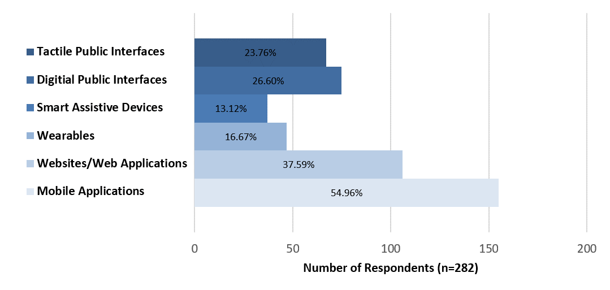
Figure 7. Number of survey participants who indicated they use/have used various categories of technology to assist with wayfinding in public spaces

Results: Facilitators related to use of wayfinding technology
Facilitating features of both personal and publicly available wayfinding technology are summarized by themes in Figures 8 to 10 below. Facilitators are summarized according to themes and presented as those commonly reported across both public and personal technologies (Figure 8), barriers for personal technologies only (Figure 9) and barriers related to public technology use (Figure 10). The personal technology category consists of mobile apps, websites, and wearable devices. Public technology includes digital and tactile interfaces.

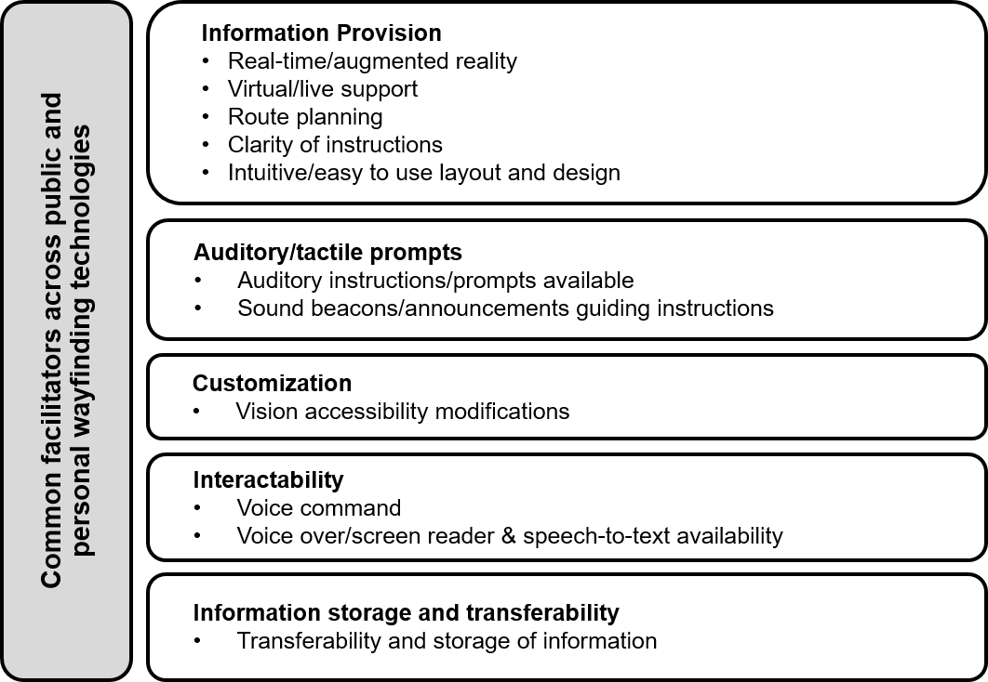

Figure 8. Main facilitators of use that are common to personal and publicly available wayfinding technology

As shown in Figure 8, common facilitator themes identified by participants for both personalized and public technology types included i) information provision, ii) auditory/tactile prompts, iii) customization, iv) interactability, and v) information storage and transferability.

i) Information provision
Information provision refers to the issues in the quality or quantity of information provided by the device or application. Facilitators mentioned by participants included the option to be able to have live updates of their location on a map and augmented features that provide a visual representation of the route. The availability of virtual/live support was a facilitator allowing one to receive direct assistance through their device when navigating. Features that allow for trip planning and visualization of the route were also reported as facilitators, along with being provided with clear instructions that are easy to understand, and application/website layout and design that is intuitive and easy to navigate.

ii) Auditory/tactile prompts
Auditory/tactile prompts were reported to be facilitating features of both personal and public wayfinding technologies. For personalized technology, participants specifically referred to the voice guidance, sound prompts and/or vibrations/haptic alerts one receives when using a device for navigation (e.g. Google map’s application voice guidance, BlindSquare’s navigation announcements, Apple Watch’s directions notifications, sound beacons). For public interfaces, the availability of signage that includes auditory cues or auditory information in addition to visual information facilitates use for pedestrians with visual disabilities.

iii) Customization
Customization refers to the ability to change the settings on a personal or public wayfinding device to make the device easier to use. Common facilitators across personal and public wayfinding technology includes the ability to make visual accessibility modifications or provide technology that include visual aid features (e.g. magnification/zoom in or out, adjust contrast, large print/font options).

iv) Interactability
Interactability is used to describe the degree to which a user can interact with a personal or publicly available wayfinding device. The ability to navigate the device and execute commands using one’s voice was a common facilitating feature that improved the usability and accessibility of public and personalized technology. Voice-over/screen reader and speech-to-text availability were additional reported features that make devices easier to interact with and facilitate their use.

v) Information storage and transferability
Participants noted that wayfinding technology features that allow a user to send directions or GPS locations to others, send directions to their phone from another device (e.g. computer or public digital interfaces), or easily print directions for use when navigating, facilitated the device’s use.

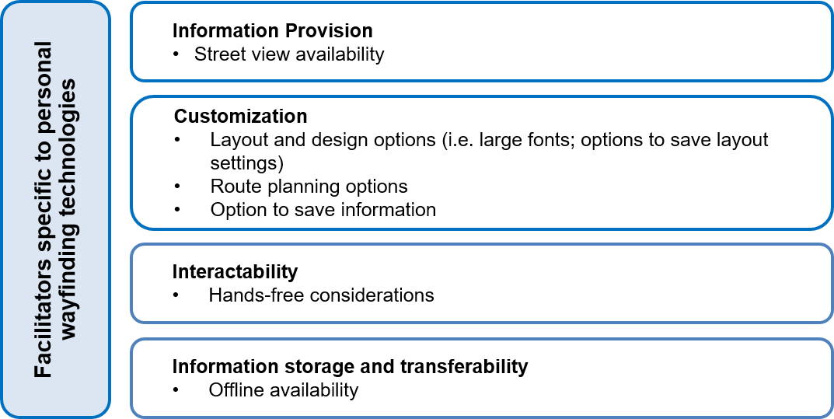

Figure 9. Facilitators Specific to Personal Wayfinding Technology (mobile apps, websites, wearables, and smart assistive devices)

As shown in Figure 9, common facilitator themes of personalized technology, as identified by participants included i) information provision, ii) customization, iii) interactability, and iv) information storage and transferability.

i) Information Provision
Participants indicated that being provided with the option to see the street view of a route and one’s location within that route was a useful feature while navigating.

ii) Customization
Overall customization of one’s personal wayfinding technology was reported to be a facilitating feature. Participant examples included having the option to modify the layout and design of an application or website, along with the ability to filter and save the information provided. Additional reported customization facilitators included the ability to filter for mobility-accessible routes, select route options, save information for easy retrieval later on, or modify and save the layout and design adjustments made on the application, website, or device.

iii) Interactability
Survey participants reported the option of having their hands free and available for other tasks (e.g., walking with a dog/cane, or pushing one’s wheelchair) while using their devices for navigation was a facilitator of use.

iv) Information storage and transferability
Technology that provides options to use navigations/directions offline, or options to save information for offline use was a reported facilitator for survey participants.

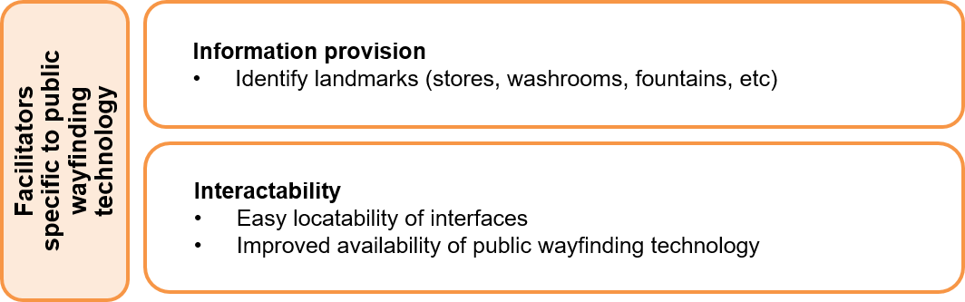

Figure 10. Facilitators Specific to Public Wayfinding Technology (digital and tactile public interfaces)

As shown in Figure 10, common facilitator themes of public wayfinding technology, identified by participants included i) information provision, and ii) interactability.

i) Information provision
Public wayfinding technology that identifies landmarks (e.g. stores, washrooms, fountains) and provides details for distinct locations along a user’s route, is beneficial to a user’s navigation experience.

ii) Interactability
When considering public wayfinding technology, interactability refers to a user’s experience accessing the device. Being able to easily locate the interfaces when they are needed, along with adequate availability of the technology, were reported by participants to the facilitators of this technology.

Results: Barriers related to the use of wayfinding technology
A sub-sample of survey participant responses (n=213) was analyzed to understand the barriers to the use of wayfinding technology. The participant demographics of this data subset are summarized in Table 2 below. The participant subsample is observationally similar to the overall participant sample for this study (Section 4.1).
Table 2. Demographic characteristics for participants reporting barriers to wayfinding technology use (n = 213)
Variable of interest | Total participants (frequency (%))
Age (years)
Mean (SD) | 49.3 (16.3)
18 to 39 years | 68 (31.9%)
40-59 years | 79 (37.1%)
60-79 years | 63(29.6%)
80+ years | 3 (1.4%)
Gender
Man | 90 (42.3%)
Woman | 115 (53.9%)
Other | 5 (2.4%)
Prefer not to answer or no response | 3 (1.4%)
Disability type
Mobility/Dexterity/Flexibility | 162 (76.1%)
Visual | 113 (53.1%)
Memory/Learning/Flexibility | 33 (15.5%)
Pain-Related | 62 (29.1%)
Hearing | 44 (20.7%)
Other | 48 (22.5%)
Prefer not to answer or no response | 9 (4.2%)
Number of Disability Types
1 | 90 (42.2%)
2 | 43 (20.2%)
3 | 20 (9.4%)
4+ | 33 (15.5%)
Prefer not to answer or no response | 9 (4.2%)
Types of assistive devices, aids, and service animals
Glasses/Contact Lenses | 71 (33.3%)
Screen-Reader/Voice-Over Devices | 52 (24.4%)
White Cane | 44 (20.7%)
Stability-Based Walking Aids (i.e. canes, walkers) | 36 (16.9%)
Service Animal | 31 (14.6%)
Visual Aids (i.e. magnification) | 23 (10.8%)
Wheeled Mobility Devices | 21 (9.9%)
Hearing Aids | 17 (8.0%)
Structural/Functional Braces | 4 (1.9%)
Not Applicable/No Response | 35 (16.4%)

Figures 11 to 13 below summarize the barriers reported by survey participants when using wayfinding technology. Barriers are summarized according to themes and presented as those commonly reported across both public and personal technologies (Figure 11), barriers for personal technologies only (Figure 12) and barriers related to public technology use (Figure 13). The personal technology category consists of mobile apps, websites, and wearable devices. Public technology includes digital and tactile interfaces.

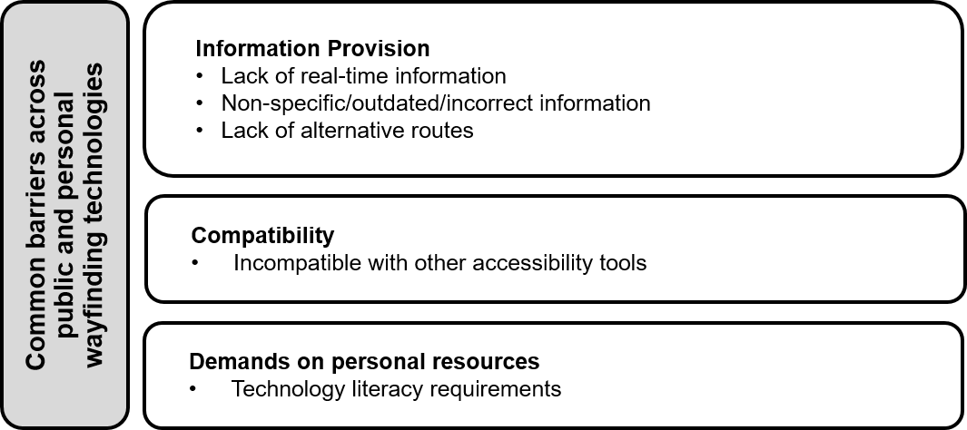
Figure 11. Barriers to wayfinding technology use that are common across personal and public technologies

As shown in Figure 11, common barrier themes identified by participants in both personalized and public technology types included i) information provision, ii) compatibility, and iii) demands on personal resources

i) Information provision
Wayfinding technologies that do not provide real-time information, or have non-specific and/or outdated information were the main barriers identified by participants related to information provision. For personalized technologies, examples provided by participants included websites that are unable to identify a user’s real-time location on the map), mobile applications with non-specific information, such as those that do not inform the user of which side of the street their destination is, and apps that do not provide updated information about construction/temporary route blockages impacting the safety and accessibility of sidewalks. For public technologies, digital maps that do not have an option for real-time information are example barriers for individuals who need to remember the route. Digital maps that do not identify the user’s exact location, and/or ones that do not maintain up-to-date locations of stores/services have also been noted as barriers. Finally, example barriers common across public and personalized technologies were related to applications only providing a single route option, despite accessibility challenges within that route (i.e. lack of alternative routes available within the technology).

ii) Compatibility
Compatibility refers to being able to use a wayfinding technology with another accessibility tool. Within both personalized and public technologies, there were example barriers that were related to the device or interface being incompatible with other tools that are required for accessible use (e.g., tactile or digital interfaces being incompatible with screen readers for blind users).

iii) Demands on personal resources
Common to public and personalized wayfinding technology use were reported technology literacy requirements demanded of individuals. Individuals noted cellphone apps that required them to be “technologically savvy” or public interfaces which are designed assuming that an individual will readily know how to interact with the technology.

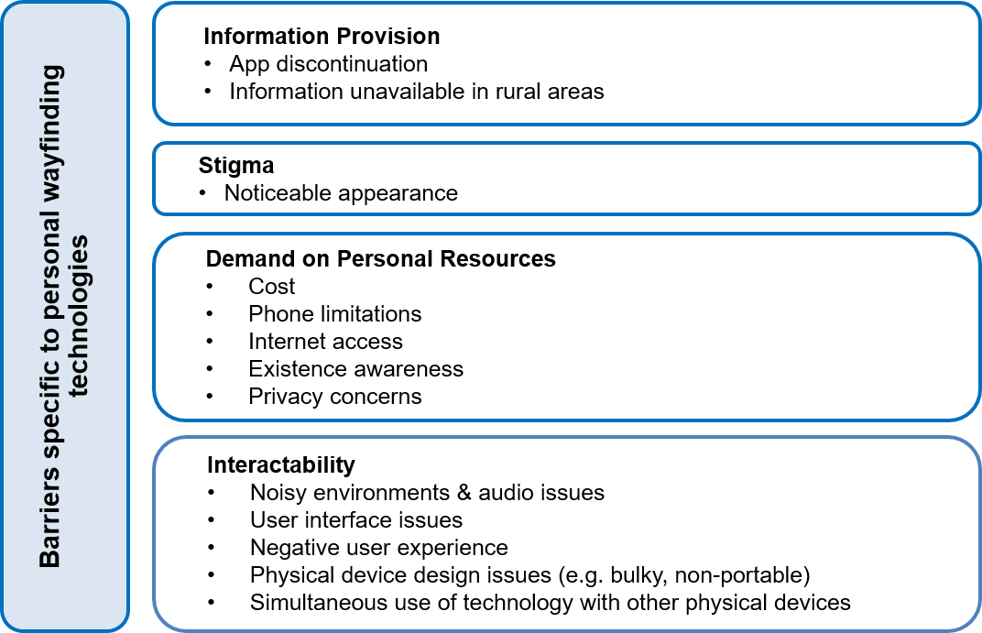

Figure 12. Barriers specific to personal wayfinding technology (i.e., mobile apps, websites, wearables, and smart assistive devices)
As shown in Figure 12, barriers identified by participants when using personalized wayfinding technology included i) information provision, ii) stigma, iii) demands on personal resources, and iv) interactability.
i) Information provision
For personalized wayfinding technology, many individuals rely on and become accustomed to, specific apps. As noted by survey participants, the discontinuation or loss of support, of an app presents as a barrier to use (noted by many was a specific app for blind users, Microsoft Soundscape, which was discontinued). Information unavailability in rural areas was also a barrier, as many technologies do not provide navigation information in rural areas.

ii) Stigma
Stigma was a barrier theme unique to wearable devices and smart assistive devices, as it refers to the device’s appearance attracting unwanted attention. For some individuals, the technology’s noticeable appearance was a barrier to use (e.g., FM systems are often visible and suggest a user’s hearing impairment).

iii) Demand on personal resources
The demand on personal resources stems from requiring the individual to employ their knowledge and finances to be able to use technology. Subthemes contributing to this barrier include cost (e.g., wayfinding applications for blind users are often financially demanding to purchase or require costly subscriptions), phone limitations (e.g., phone signal is scarce if a user lives in a rural area), Internet access (e.g., most navigation applications require data or Wifi, which are not often available or affordable), and existence awareness (e.g., not knowing a device or application exists).

iv) Interactability:
Interactability refers to the way a user interacts with the device. Specific to personalized technology use, survey respondents noted difficulties in noisy environments and other audio issues when using apps or wearables (e.g., blind users being unable to hear the directions from their mobile application when on a traffic-heavy road). User interface issues (e.g., small font size or decreased contrast on a website), negative user experience (e.g., unresponsive websites), and privacy concerns (e.g., having to provide personal data to sign into an application) were also described by survey respondents as barriers to personalized technology use. Many personalized devices require the user to hold/don a smart assistive device or wearable device that is bulky or heavy. Finally, the simultaneous use of personalized technology with other physical devices was also an example interactability-related barrier (e.g., self-propelling a wheelchair with both hands while having to use a cell phone to navigate).

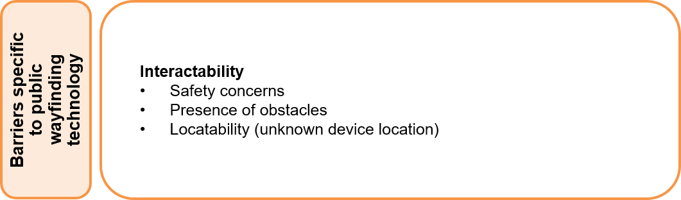

Figure 13. Barriers specific to public wayfinding technology (i.e., digital and tactile public interfaces)

As shown in Figure 13, barrier themes identified by participants when using public technology types included i) interactability

i) Interactability:
Examples of interactability barriers included safety concerns with using public interfaces post-COVID-19; many people noted they did not feel safe touching/interacting with public interfaces (such as public tactile kiosks/signs) due to infection risk. Survey participants also noted the presence of physical obstacles (such as planters, benches, and signage boards) around a public interface as a barrier to use. These obstacles interfered with the safe use and locatability of public technology. The inability to find the public interface was also a barrier for individuals where reliance on vision to locate the tool was required. For those who identified as having a visual disability, the inability to generally use a touchscreen digital interface was frequently noted.

Co-Designing Wayfinding Technology Standards: Identifying Key Themes for Wayfinding Technology for People With Visual Impairment/Visual Disabilities
In addition to our national survey, we facilitated a discussion on the experiences of individuals who use technology for wayfinding as part of a co-design workshop hosted by the Canadian National Institute for the Blind (CNIB). The discussion explored views on technology use and barriers to the use of technology available for wayfinding. Participants were also invited to provide their views on how to best include wayfinding technology in accessibility standards, including co-designing recommendations or specifications that should be considered for standard development.

Co-design workshop methods
The wayfinding technology co-design workshop was conducted over a single session, lasting 1.5 hours. Several guiding questions were used to facilitate the workshop discussion, including:
Question #1: Please describe your general wayfinding experiences and any challenges with respect to wayfinding in public spaces? Do your experiences and challenges differ if you are navigating indoor or outdoor spaces?

Question #2: Given that there is an increased availability and use of tech for wayfinding, can you share with us what technologies you currently use or have used? Including,
- Any barriers to the technology?
- What do you like about them? How do they help you?

Question #3: What would you hope wayfinding tools or technologies could do that they do not currently do?

Question #4: What parameters would you want to see included in an accessibility standard? Think about for individual technology available, or for technologies available within the environment

Question #5: Final thoughts about the use of technology for wayfinding? Any other resources, or suggestions to improve (a) uptake, (b) real-time use, (c) access to technology?

Two researchers transcribed the workshop discussion. Participant remarks were summarized regarding experiences of using technology for wayfinding, or when navigating the built environment and public spaces, and recommendations for inclusion within accessibility standards.

Summary of co-design workshop findings
Table 3 provides a summary of themes related to the use of wayfinding technology, associated barriers/facilitators to the technology use, and recommendations for inclusion in accessibility standards to address barriers and/or support facilitators as discussed by participants. The key themes guiding the co-designed recommendations were affordability, maintenance and safety, consistency, information provision, and education. A detailed summary of each theme is provided following Table 3, including supportive, example quotes from participants.
Table 3. Summary of themes related to use of wayfinding technology, discussed barriers to the use of technology, and recommendations discussed by participants for inclusion in accessibility standards
Theme | Barriers to wayfinding technology use | Recommendation to address barrier
Affordability | - High data consumption when using a mobile device to assist with wayfinding.  - Cost as a barrier to accessing wayfinding tech/apps. | - Availability/accessibility of mobile data for those who rely on it for wayfinding.  - Provision of tech (phone, apps, internet, TV) discounts for individuals who need them
Maintenance and Safety | - When publicly available accessibility tools and features are not frequently maintained, it poses safety risks and creates challenges during navigation. | - Continuous/standardized maintenance practice for public accessibility tools and features.
Consistency | - Inconsistent placement and design of certain design elements for public wayfinding tools create challenges.  - Difficulty locating QR codes on documents or public signage.  - Barrier in getting to final destinations | - Consistency of the design of public wayfinding tools (e.g., accessible door buttons, signage placement, and placement of temporary obstacles).  - Standardized locatability of QR codes (e.g., consistent location placement on documents/websites or on public interfaces; instruction or use of audio cue to direct individual to the QR code)  - More frequent use of publicly available audio beacons
Information Provision | - Challenges are faced when entering and navigating an unfamiliar space; difficulty orientating and knowing how to engage with the space  - An app presenting a user with a large quantity of information can function as either a barrier or a facilitator, depending on the individual’s preference | - Providing multimodal engagement (audio, visual cues) at the point of entry to assist with orientation.  - Flexibility of tech to provide a preferred amount of information (i.e., choice)
Education |  | - Inclusivity and accessibility training for employees in public spaces where wayfinding technologies are available for use

Identified themes are discussed in detail below; supportive quotes from workshop participants are provided under each theme, selected to represent the ideas discussed by the group.

Theme 1: Affordability
Affordability exists as a barrier to accessing wayfinding technology and applications, as mobile navigation apps often require mobile data usage for use without internet connectivity - which is frequently unavailable when navigating to a location. The discussion group expressed how mobile data for daily navigation should be accessible without additional costs. A participant explained that for spaces that deploy a navigation tool, there should be a standard for how one would connect to the internet if it is available.

Regarding the cost of mobile applications, one participant stated that it “adds up when you must pay for multiple apps”. Another participant shared the surprise she experienced when receiving a significantly low phone discount that was only open to small businesspeople, and how people who need cell phones [for navigation], don’t have access to those such discounts:

“Costco’s discount on phones was only open to small businesspeople, plans costs were so low we couldn’t believe it. With the amount of data we got, I can’t believe it was only open to people with small businesses and that people who need cell phones don’t have the option of getting that same plan.”

Wearables and smart assistive devices can also aid one's wayfinding experience, however, the high costs of these technologies and their lack of insurance coverage, generally prevented the group from accessing and exploring the use of such devices. Given the reliance on mobile data, the recommendations to address affordability included mandatory available discounts for individuals who need it.

Theme 2: Maintenance and Safety
The theme of maintenance and safety was discussed by participants, resulting from the safety risks and the challenges created when publicly available wayfinding tools are not frequently maintained. During the discussion, the group expressed that without regular maintenance of wayfinding systems, they often had to compromise on safety. One participant specifically mentioned that the Accessible Pedestrian Signal (APS) system at intersections is often not functioning and that during the winter the pedestrian area at crossing lights is not always shovelled. The participant explained that the lack of maintenance prevents a pedestrian from navigating via their ideal route:

“Simple methods are becoming harder to find but the municipality is not putting in the effort into old developments and making them universal for everyone. We must take the long way because we look for the safest way as opposed to the simplest way. If certain lights aren’t working, you must walk far to cross the road.”

To address this barrier, continuous/standardized maintenance practice for public accessibility tools and features is recommended.

Theme 3: Consistency
Consistency exists as a barrier that prevents individuals with disabilities from arriving at their destination when wayfinding, as inconsistent placement, and arrangement of certain design elements (e.g. signage, door-opening buttons) for public wayfinding tools, create challenges. The focus group session discussed some of the design elements of buildings, and how inconsistent placement and design of elements pose challenges to the participants. An example from the discussion related to the accessibility button that is used to open doors, and how they should be universal in size, shape, and location, for easy recognition. One participant shared with the group that at their daughter’s school they had a difficult time locating the button because it was rectangular and was not in an obvious place and another participant agreed and stated that “sometimes the push buttons are in the most obscure places”.

A different participant said that signage sometimes blocks accessibility buttons or public wayfinding interfaces. They spoke of an experience they had while trying to access an accessibility button, where they ended up accidentally kicking a sign that was in their path while trying to push the button. The participant referred to himself as a very confident traveller but said this situation made them feel like an idiot.

Difficulties in locating QR codes on documents or public signage also stem from the lack of consistency in their placement and locations. A participant explained that QR codes are used in part of their planning process when determining a route, however, the hard part is finding the QR codes. QR codes that are found on the floor of malls were mentioned as barriers though their increased use is known; as discussed by the group, for someone who is not sighted locating the QR code is very challenging

A participant suggested that there needs to be a standard for the consistency of the physical location of a QR code, if used. The participant explained that they recognize the clipped top corner of the paper to know that it is the front of the page, and then look for the QR code at the bottom. As suggested by the group, in public spaces, a cue directing the individual to the interface/QR code would support use
Audio beacons were described throughout the session as a tool that can facilitate wayfinding for individuals with vision loss or visual impairments, and “provide clearer details than areas that aren’t equipped with it” as stated by a participant. Another participant expressed that having the flexibility that audio beacons provide is certainly helpful and can tell them whether they are getting closer to their destination. In the session, an individual suggested that it “would be nice if when walking by a store the beacons allow for the store name to get announced”. When probed about potential problems with audio beacon systems, one participant responded:

“beacons have to be maintained, and if it’s going to be a burden to the individual, they won’t be very useful. Maintenance would make the tools more enabling and useful to use when entering a building or a new space.”

Theme 4: Information Provision
Participants explained that challenges are faced when entering and navigating an unfamiliar area and that they have difficulties orientating themselves and knowing how to engage with the space. One participant expressed the challenges one faces when entering and navigating a new space, and how multimodal engagement can be beneficial in combatting this barrier:

“When you come into a space, there’s not a standard where you get time to orient yourself. The multimodal engagement should begin when you enter the space and should be standardized. Where is that video screen that’s going to help you, or the QR code you can engage with so that you know to turn on your apps or how to engage? Currently, it is not consistent and not always there. Even as we came into this space here, I had no idea how big the space is or where to sit. We can start with standards of how the signage and layout are going to be.”

The large quantity of information a mobile application presents a user with can function as either a barrier or facilitator, depending on the individual’s preference. For example, a participant in the discussion mentioned that wayfinding apps present a user with a large quantity of information and being able to manage the flow of all the information presented, is a challenge:

“How do I manage that information flow? Because I don’t need the app to assume what it wants to tell me. I want to be able to manage that verbosity and many apps can’t do that. When entering a space – how do I know this space is supported through accessible technology (e.g. app, Be My Eyes, Guide)? Knowing as I am coming into a space, knowing that it has a tech tool I can use.”

In contrast, another user stated that they prefer the high quantity of information that may come from an app, so they can narrow it down. To address this discrepancy, the group discussed the need for flexibility of technology to provide a preferred amount of information (i.e. choice)

Theme 5: Education
The potential benefits of implementing mandatory education, specifically inclusivity and accessibility training for employees in public spaces where wayfinding technologies are available for use was briefly discussed. To help create a more inclusive society and increase the accessibility of a given environment, one participant recommended that education regarding inclusivity and accessibility needs should begin in schools:

“Should start in school where it becomes a rule: [there then] shouldn’t be barriers because you’ve learned about this in school since we learn most things at a young age. Simple considerations and teachings should be taught at a young age.”

Moving Forward: Considerations for the Accessibility, Usability, and Standardization of Wayfinding Technology for People With Disabilities
This project aimed to develop considerations for the inclusion of various elements of wayfinding technologies within accessibility standards. We have summarized our recommendations below according to the functional implications of addressing the barriers and facilitators to wayfinding technology use that were identified through our national survey including individuals with various disabilities and co-design workshop with CNIB members. Considerations for the accessibility, standardization, and usability of wayfinding technology are subdivided into those that:
  - Support decision-making processes for individuals;
  - Support the organization and communication of information;
  - Support use in real-world public settings; and
  - Provide broader support for the use and implementation

Support for decision making
Decision-making is critical for successful wayfinding. Route familiarity, external environmental conditions, and trip purpose all contribute to the complexity of the decisions required along the journey (Harms, Burdett, & Charlton, 2021). Decisions occurring during the orientation and route selection steps of wayfinding (Charisse Farr, Kleinschmidt, Yarlagadda, & Mengersen, 2012), along with decisions made during active navigation, may affect one’s route safety, efficiency and comfort.
As identified through this research, consideration of various elements of smart navigation systems, mobile apps, websites, and digital maps, can support decision-making throughout one’s wayfinding journey in several ways. For example, flexibility in route planning options would allow individuals to plan their routes in advance of a trip or rely upon automated route guidance, depending on one’s preference. Route planning that allows for route characteristic selections may allow for customized options depending on one’s disability and/or needs (e.g., wheelchair users being directed via routes with ramps, not stairs), or preference for one mode of transportation over another (e.g., a bus with accessible features over a streetcar with steps). Landmarks are critically important reference points for orienting and understanding one’s relative location and reasoning about an environment (Brunyé, Gardony, Holmes, & Taylor, 2018); wayfinding technology with the option of greater specificity of information, including important landmarks and waypoints, would support decision-making throughout one’s journey. Accurate, up-to-date and real-time information provision is crucial for changing routes/mode of transportation to reflect emerging barriers for pedestrians, such as traffic collisions, temporary construction obstructions, new building access points, breakdown/maintenance of elevators, noise levels, and weather events affecting routes. Wayfinding technology that can reliably locate and orient a person in real-time and provide relevant and accurate instructions, would be beneficial for navigation and increase the traveler’s level of confidence (Murdoch, Pey, & Brooks, 2022). A clear visual representation of the user on the route would help one understand the direction of travel and improve their spatial awareness.

Considerations for supporting decision making provided by wayfinding technology include:
- Flexibility in route planning
- Specificity of information including identification of specific landmarks (e.g., washrooms, information podiums, bus stops, elevators) and waypoints (e.g., identifiable features such as fountains)
- Up to date, accurate, information
- Real-time information and flexibility of re-routing
- Clear/visual audible representation of the user on route

Organization and communication of information
The way information is organized and communicated to the user is crucial for correct and efficient interpretation. Misunderstanding information or the inability to find details can lead to delays and errors in navigation. Having good orientation allows one to navigate with more ease and efficiently re-route when their planned route is disrupted (Anacta, Schwering, Li, & Muenzer, 2017).
To address barriers or support facilitators of wayfinding technology use identified through this research, there are many elements of public and personalized wayfinding technology where the organization and communication of information should be considered. Presenting information using plain language techniques, and in a way that can be easily navigated, is important to address language and technology literacy barriers for many individuals (Stableford & Mettger, 2007). The ability to manage the quantity and complexity of information provided may facilitate technology use for wayfinding, particularly considering the diverse needs of individuals with disabilities. One of the largest barriers indicated through our research was that of inaccessible websites/mobile apps; accessibility of the applications that provide the wayfinding information is critically important to ensure barriers are removed, including the ability to individually customize settings and features (e.g. font size, audio). If adhered to, current web content and mobile application standards exist that would address these accessibility barriers (Web Content Accessibility Guidelines, n.d.). Finally, while many organizations or public spaces are adopting publicly available wayfinding technology (such as individual tactile maps, and audio loop systems), appropriate communication of such available resources before, and at arrival, is necessary to ensure that individuals with disabilities are aware of the existence of the tool and can access it if desired.

Considerations for supporting organization and communication of information provided by wayfinding technology include:
- Ease of information access
- Information presented in plain language for diverse communication and accessibility needs
- Web content and apps follow the most up-to-date web accessibility guidelines (WCAG) regarding presentation, organization and allowance for accessibility features
- Individual customization of settings and features (e.g., font sizes, volumes, caption settings)
- Availability of virtual/live support
- Flexibility in quantity and complexity of information provided
- Privacy of information collected and transmitted
- Communication of which public wayfinding resources are available at a site, including use of important safety alerts features

Supporting use in real-world public spaces
The user experience with wayfinding technology can be substantially different in a controlled environment, compared to using the device in the real world. Noise, other pedestrians or vehicles, weather, maintenance policies, construction or other obstacles along one’s route may present as barriers to the locatability of publicly available wayfinding tools, and/or the usability of both public and personalized wayfinding technologies.
It is well-known that multi-modal interfaces can support diverse users and usage contexts (Oviatt & Cohen, 2015). By combining various sensory cues (i.e., audio, visual, tactile), public interfaces that provide wayfinding information would better address individualized needs and/or the intersectionality of disabilities, where reliance on a single modality for locating, accessing, and conveying information may present a barrier for many (Giudice, Guenther, Jensen, & Haase, 2020). Standardization of public tools (e.g., a menu will always appear at the top left of a digital public interface, audio controls at the top right, and a QR code to access information on a personal device on the bottom right) allows the user to access information more immediately rather than having to learn a new technology on the spot. The tools must also perform well under real-world conditions, where noise and other distractions may be present. Personalized wayfinding technology (e.g., mobile apps) may also require the individual to manage their device or take their device out of their pocket repeatedly, while also operating their mobility aid, such as a wheelchair (Murdoch, Pey, & Brooks, 2022). This additional physical barrier can increase the physical demands of the task and/or create additional cognitive load for the user, and for blind and low-vision individuals especially, it also exposes one to an even higher risk of crime specifically when they are required to advertise their possession of a device or smartphone (Murdoch, Pey, & Brooks, 2022). Hands-free options (including speech-to-text features, and audio commands) support the simultaneous use of personalized wayfinding technology with other assistive devices. Similarly, device compatibility with other accessibility tools (such as screen-readers) ensures accessibility of the technology, while also potentially reducing the physical and cognitive demands. In a public setting, digital or tactile interfaces may require physical contact by the user; in a post-COVID era, maintenance and cleanliness of public interfaces supports safety. This is important since internet connectivity and mobile data are not always available, which limits where and when personalized wayfinding technology is used. Finally, consideration of the end-to-end experience contributes to full accessibility and inclusivity; the user should have a seamless experience, including planning the journey, actively navigating, learning about and using accessibility features they may need, arriving at a destination, and communicating with support.

Considerations for supporting wayfinding technology use in real-world public spaces include:
- Availability of multi-modal information
- Use of safety alert features in multi-mode formats
- Standardization and consistency of design features in public interfaces
- Clearance of physical (e.g., trash bins) and sensory (e.g., poor lighting, noisy speaker or fan interference) barriers to public interfaces
- Maintenance, cleanliness and safety of public interfaces
- Performance of tool in noisy environments
- Compatibility with other accessibility tools
- Hands-free use, audio commands, speech-to-text features
- Robust offline features to overcome connectivity barriers
- End-to-end experience

Broader support of wayfinding technology use and implementation
Beyond inclusion in accessibility standards, support for the use and implementation of wayfinding technology can be achieved in several ways. One of the most cited barriers to the adoption and continued use of personalized wayfinding technology was that of cost. Technology adoption can be financially straining for many, but especially so for people with disabilities as many individuals do not have the financial resources required to purchase new technology or upgrade their existing ones (Lupton & Seymour, 2000). For wayfinding tools specifically, the requirement to have updated mobile technology, costly apps to download, and constant connectivity requires funding support. Support of education, including training for employees in public spaces and support for individuals to learn about various technologies available to assist with wayfinding, would ensure that accessible solutions are more easily adopted without barriers. Connectivity in rural and challenging areas (e.g., in subway tunnels) is a barrier to using wayfinding tools. System-wide improvement in connectivity will improve access and usability of wayfinding technology.
A barrier to using technology is confidence and trust in the source of the technology and the information provided by the technology. A centralized resource incorporating information about the developers and managers of a technology, the features of the technology, information about how personal user information is used and stored, and public feedback regarding the performance of the technology would be valuable to assist in learning about new wayfinding technology and making confident decisions regarding whether the technology is suited to the end user. Development of technology with the support and inclusion of people with disabilities, through co-design and testing, contributes to better real-world performance.

Considerations for the broader support of wayfinding technology use and implementation include:
- Funding supports for individuals to adopt technology
- Funding support for organizations to increase implementation of various technologies (e.g., Increased use of audio beacons, tactile maps etc. in public spaces)
- Education and social supports (i.e., providing services to connect individuals with education to improve awareness of tools/tool use; technology literacy support)
- Education support for professionals to reduce attitudinal barriers, ageism, ableism, and other forms of discrimination
- Support for accessibility training for employees, or support for accessibility specialists
- Funding and education for inclusion of people with disabilities in the technology co-design and testing processes
- Centralized source for information and reviews regarding available technology and education for use
- Improved internet connectivity
- Privacy by design, with tracking and monitoring optional but leading to no performance decline

Glossary of Terms

Accessibility: To enable persons with disabilities to live independently and participate fully in all aspects of life (United Nations, n.d.).

Compatibility: Refers to being able to use a wayfinding technology device with another accessibility tool.

Digital public interfaces: This category of wayfinding technology includes solutions that provide individuals with wayfinding information in public spaces. Examples of digital public interfaces are digital maps or digital kiosks.

Disability: Defined within this report as an overarching term, encompassing an individual’s presenting impairments or limitations and their interaction with external barriers that can impact involvement in society.

Information provision: Refers to the issues in the quality or quantity of information provided by the device or application.

Interactability: The degree to which a user can interact with a device. For mobile apps, websites, wearables, and smart devices, this is dependent on the physical features of the device. For digital and tactile devices, the degree to which a user can interact with the device is dependent on its availability and the ease with which it can be located.

Mobile applications: Category of wayfinding technology; includes applications for smartphones, personal digital assistants (PDAs), and special tablets.

Personal resources: Resources an individual can access that are beneficial for acquiring and/or using technology. Examples include finances, internet access, and technology literacy and skills.

Personalized wayfinding technology: Personal devices an individual would need to acquire for their use, including mobile applications, websites, wearable devices, and smart assistive devices.

Public wayfinding technology: Technologies located in public areas, which are shared amongst the population. These public technologies include digital and tactile interfaces.

Smart device: A category of wayfinding technology comprised of devices that utilize smart technology to assist the user. Example of this type of wayfinding technology includes physical assistive devices, such as white canes and wheelchairs, which have embedded sensors, actuators, and/or communication features to detect obstacles and assist with route selection within an environment.

Tactile public interface: This type of wayfinding technology includes solutions that provide individuals with accessibility information in public spaces, through the sense of touch. An example includes maps with raised features or 3-D maps.

Wayfinding technology: Systems or innovations that exist beyond traditional architectural elements. Wayfinding technologies and tools have been grouped into 6 categories (Prandi, Barricelli, Mirri, & Fogli, 2023) in this study: (1) mobile applications, (2) website applications or websites, (3) wearable devices, (4) “Smart” assistive devices or assistive devices with embedded sensor/communication features, (5) digital public interfaces, and (6) tactile public interfaces.

Wearable device: A category of wayfinding technology consisting of devices designed to be worn by the user. This type of wayfinding technology includes smart glasses, smart watches and other smart objects that the user may wear to obtain real-time information about the environment and instructions for moving inside it.

Web application: This wayfinding technology category includes applications sourced through websites, and are mainly designed to support wayfinding and/or identify accessibility information of places and roads.

- References
Anacta, V. A., Schwering, A., Li, R., & Muenzer, S. (2017). Orientation information in wayfinding instructions: evidences from human verbal and visual instructions. GeoJournal, 82, 567–583. doi:https://doi.org/10.1007/s10708-016-9703-5
Brunyé, T. T., Gardony, A. L., Holmes, A., & Taylor, H. A. (2018). Spatial decision dynamics during wayfinding: intersections prompt the decision-making process. Cognitive Research: Principles and Implications, 3. doi:https://doi.org/10.1186/s41235-018-0098-3
Centers for Disease Control and Prevention, National Center on Birth Defects and Developmental Disabilities. (2020, September). Common Barriers to Participation Experienced by People with Disabilities. (U. D. Services, Producer) Retrieved August 2023, from https://www.cdc.gov/ncbddd/disabilityandhealth/disability-barriers.html
Charisse Farr, A., Kleinschmidt, T., Yarlagadda, P., & Mengersen, K. (2012). Wayfinding: A simple concept, a complex process. Transport Reviews, 715-743. doi:https://doi.org/10.1080/01441647.2012.712555
CSA Group. (2018). Accessible design for the built environment. Toronto, ON: National Standard of Canada. Retrieved from https://www.csagroup.org/wp-content/uploads/B651-18EN.pdf
Frizziero, L., Liverani, A., Donnici, G., Papaleo, P., & Leon-Cardenas, C. (2021). Smart Cane Developed with DFSS, QFD, and SDE for the Visually Impaired. Inventions, 6(3), 58. doi:doi.org/10.3390/inventions6030058
Giudice, N., Guenther, B., Jensen, N., & Haase, K. (2020). Cognitive Mapping Without Vision: Comparing Wayfinding Performance After Learning From Digital Touchscreen-Based Multimodal Maps vs. Embossed Tactile Overlays. Frontiers in Human Neuroscience, 14. doi:https://doi.org/10.3389/fnhum.2020.00087
Harms, I. M., Burdett, B. R., & Charlton, S. G. (2021). The role of route familiarity in traffic participants’ behaviour and transport psychology research: A systematic review. Transportation Rsearch Interdisciplinary Perspectives, 9. doi:https://doi.org/10.1016/j.trip.2021.100331.
Lau, S.-T., Nirmalanathan, K., Khan, M., Gauthier, C., Maisel, J., & Novak, A. (2020). A Canadian Roadmap for Accessibility Standards. Toronto, ON: Canadian Standards Association. Retrieved from https://www.csagroup.org/article/research/a-canadian-roadmap-for-accessibility-standards/
Lupton, D., & Seymour, W. (2000). Technology, selfhood and physical disability. Social Science & Medicine, 50(12), 1851-1862. doi:https://doi.org/10.1016/S0277-9536(99)00422-0.
Marcoe, J., Pateman, H., & Venhola, L. (2022).
Montuwy, A., Cahour, B., & Dommes, A. (2019). Using Sensory Wearable Devices to Navigate the City: Effectiveness and User Experience in Older Pedestrians. Multimodal Technologies and Interaction, 3(1), 17. doi: https://doi.org/10.3390/mti3010017
Morris, S., Fawcett, G., Brisebois, L., & Hughes, J. (2018). Canadian Survey on Disabilities: A demographic, employment and income profile of Canadians with disabilities aged 15 years and over, 2017. Statistics Canada. Retrieved from https://www150.statcan.gc.ca/n1/pub/89-654-x/89-654-x2018002-eng.htm
Murdoch, T., Pey, T., & Brooks, E. (2022). A step towards truly independent access for everyone, everywhere. Assistive technology : the official journal of RESNA, 34(6), 668-672. doi:https://doi.org/10.1080/10400435.2021.1954109
Oviatt, S., & Cohen, P. R. (2015). Aims and Advantages of Multimodal Interfaces. The Paradigm Shift to Multimodality in Contemporary Computer Interfaces. Synthesis Lectures on Human-Centered Informatics. doi:https://doi.org/10.1007/978-3-031-02213-5_3
Prandi, C., Barricelli, B., Mirri, S., & Fogli, D. (2023). Accessible wayfinding and navigation: a systematic mapping study. Universal Access in the Information Society, 22(3), 185-212. doi:https://doi.org/10.1007/s10209-021-00843-x
Stableford, S., & Mettger, W. (2007). Plain Language: A Strategic Response to the Health Literacy Challenge. Journal of Public Health Policy, 28(1), 71-93. doi:https://doi.org/10.1057/palgrave.jphp.3200102
United Nations. (n.d.). Convention on the Rights of Persons with Disabilities (CRPD), Article 9 – Accessibility. Retrieved from https://social.desa.un.org/issues/disability/crpd/convention-on-the-rights-of-persons-with-disabilities-crpd
Web Content Accessibility Guidelines. Latest version. Retrieved from https://www.w3.org/TR/WCAG/
World Health Organization (WHO) and the United Nations Children's Fund (UNICEF). (2022). Global report on assistive technology. Retrieved from https://www.who.int/publications/i/item/9789240049451

Appendix A – Summary of environmental scan results of wayfinding technologies included in accessibility legislation, codes, standards, guidelines

Table A-1. Detailed summary of international accessibility legislation, standards and guidelines included in the environmental scan that contain aspects of wayfinding technology.

Name of Standard | Author | Year Published | Description of the Wayfinding Technology Included in the Document | Location in Document
Accessibility Code for Building Construction | State of Florida | 2012 | Assistive listening system: Requirement to include assistive listening systems in buildings of assembly occupancy, including international access symbol to indicate availability | Page 39, Section 219
ADA Standards for Accessible Design | US Department of Justice | 2010 | Assistive listening systems: Requirement to include assistive listening systems in buildings of assembly occupancy, including international access symbol to indicate availability and compatibility requirements | Page 73, Section 216.10, 219, 706
Australia Accessibility Design Guide: Universal design principles for Australia's aid program | Australian Government | 2009-2014 | Audio/visual public interfaces: Description of locatability and interactibility of public access terminals, including audio and tactile responses to indicate use | Page 96-97, Section 3.2
Australia Accessibility Design Guide: Universal design principles for Australia's aid program | Australian Government | 2009-2014 | Website applications: Description of requirements for accessible website design | Page 97-98, Section 3.5
Europe Wayfinding at Airports, a LAirA Project Report | Interreg Central Europe, European Union European Regional Devt Fund | 2019 | Mobile applications: Provision of updated information within smartphone mapping applications to help the individual navigate the airport | Page 18, Figure 28
Illinois Accessibility Code | Capital Devt Board | 2018 | Assistive listening system: Description of the application and design requirements for assistive listening systems | Page 51, Section 219
Inclusive, Audio-based, Network Navigation Systems for All Persons including those Who are Blind/Low Vision (ANSI/CTA-2076) | Consumer Technology Association | 2019 | Mobile applications/smart devices/public interfaces: standard describes accessibility requirements for inclusive audio-based network navigation systems, including beacon-based location, software-based location, Wi-Fi, Bluetooth, electromagnetic signals, Ultra-Wide Band, location-based algorithms, and smart device components
International Building Code | International Code Council (ICC) | 2021 | Assistive listening systems: Requirement for the inclusion of assistive listening systems in buildings of assembly occupancy | Page (11)-10, Section 1109.2.7
ISO 19029 Accessible Design- Auditory guiding signals in public facilities | International Organization for Standardization (ISO) | 2016 | Audio/visual public interfaces: Specifications for the sound characteristics, design and usage of auditory guiding signals to provide location and direction information of public facilities | Page 3-4, Section 3.2
JIS T 0901:2011 Guidelines for older persons and persons with disabilities -- Information presentation using electronic guiding and wayfinding system | Japanese Industrial Standard | 2011 | Audio/digital public interfaces: Requirements for public user terminals, including user controls for volume, contrast, information presentation speed and operability | Page 3, Section 4.1
New York Building Code | New York Government | 2014 | Assistive listening systems: Requirement for the inclusion of assistive listening systems in buildings of assembly occupancy | Chapter 11, Section 1108.2.7
NSW Wayfinding for Healthcare Facilities | New South Wales Government | 2022 | Mobile applications: General description to use beacons or similar technology, like BlindSquare App, for wayfinding accessiblity | Page 37
NSW Wayfinding for Healthcare Facilities | New South Wales Government | 2022 | Digital/audio public interfaces: Use of digital screens, visual announcements, hearing augmentation systems | Page 37
NSW Wayfinding for Healthcare Facilities | New South Wales Government | 2022 | Digital public interfaces/mobile applications: Description of application and design requirements for accessible digital public interfaces and personalized digital technologies (e.g., mobile apps) | Page 60-65
Texas Accessibility Standards | Texas Department of Licensing & Regulation | 2012 | Assistive listening systems: Requirement for the inclusion of assistive listening systems in buildings of assembly occupancy | Section 219, Chapter 2
Wayfinding and Signage Guidelines for Airport Terminals and Landside | Airport Cooperative Research Program, Federal Aviation Program, Transportation Research Program of the National Academies | 2011 | Digital public interfaces: General considerations for the integration of digital, interactive tools within airport wayfinding systems | Page 110-112, Section 6.4.1.3; Page 195, Section 7.2.27

Table A-2. Detailed summary of national accessibility legislation, standards and guidelines included in the environmental scan that contain aspects of wayfinding technology.

Name of Standard | Author | Year Published | Description of the Wayfinding Technology Included in the Document | Location in Document
Accessible Transportation for Persons with Disabilities Regulations | Canadian Transportation Agency (CTA) | 2019 | Automated Self-Service Kiosks: Requirements related to the accessible design and use of kiosks | Page 6
CAN/CSA B651-18 Accessible Design for the built environment | Canadian Standards Association (CSA Group) | 2018 | Assistive Listening Systems: Description of the type of assistive listening system to be used, if provided | Page 139, Section 6.6.1
CAN/CSA-B651.2:22 Accessible design for self-service interactive devices | Canadian Standards Association (CSA Group) | 2022 | Digital/audio/visual public interfaces: Standard specifies minimum accessibility requirements for self-service interactive devices (such as, but not limited to, automated banking machines, retail self-checkout, self check-in devices, ticket vending kiosks, smart card sales, query and reload devices); includes application and design requirements
CSA Z317.14:17 (R2022) Wayfinding for health care facilities | Canadian Standards Association (CSA Group) | 2017 | Digital maps, public interfaces: Description of the incorporation of digital technology used for wayfinding; requirements described for general use, interactive maps, digital kiosks, audio signage, mobile technologies, websites | Page 35, Section 6.19.1
CSA Z317.14:17 (R2022) Wayfinding for health care facilities | Canadian Standards Association (CSA Group) | 2017 | Assistive listening devices: Requirement to include induction loop systems available at information desks in healthcare facilities | Page 39, Section 7.2.1.2
Intercity Bus Code of Practice | Transport Canada | 2011 | Digital public interfaces: Description to include at least one accessible digital kiosk, where kiosks are provided | Page 13, Section 4.7
National Building Code of Canada | Canadian Commission on Building and Fire Codes | 2020 | Assistive Listening Systems: Requirement to include assistive listening systems in building of assembly occupancy; considerations for design requirements provided within appendices | Section 3.8.2.9; 3.8.3.19.A-3.8.3.19.
National Building Code of Canada | Canadian Commission on Building and Fire Codes | 2020 | Digital public interfaces: Description to include multi-modal formats for digital public signage | Sentence A-3.8.2.10.(4)
Removing Communication Barriers for Travellers with Disabilities: Code of Practice | Canadian Transportation Agency (CTA) |  | Digital public interfaces: Requirements for the accessible design of automated self-service kiosks (including reference to CAN/CSA-B651.2-07) | Page 3-6, Section 1.3

Table A-3. Detailed summary of provincial accessibility legislation, standards and guidelines included in the environmental scan that contain aspects of wayfinding technology.

Name of Standard | Author | Year Published | Description of the Wayfinding Technology Included in the Document | Location in Document
BC Building Code | Government of British Columbia | 2018 | Assistive Listening System: Requirement to include assistive listening systems in buildings of assembly occupancy | Section 3.8.2.9., Division B
GO Transit Accessibility Guide Accessibility Services for Customers | Metrolinx | 2017 | Website/mobile applications: Description of accessible format available for smartphones and tablets; ensuring website is compatible with "Voice Over" assistive technologies | Page 26,27
Manitoba Building Code | Government of Manitoba | 2017 | Assistive Listening System: Requirement to include assistive listening systems in buildings of assembly occupancy | Page 18, Section 3.8.3.7
Manitoba Customer Service Standard Regulation Man Reg 171/2015 | Government of Manitoba | 2019 | General assistive technology use: Requirement for training of employees to understand use of equipment or assistive devices available for people with disabilities | Section 13(2)
New Brunswick Barrier-Free Design Building Code Regulation | Government of New Brunswick | 2021 | Assistive Listening System: Requirement to include assistive listening systems in buildings of assembly occupancy | Page 26, Section 3.8.3.18.
Newfoundland and Labrador Buildings Accessibility Regulations | Government of Newfoundland and Labrador | 2018 | Assistive Listening System: Requirement to include assistive listening systems in buildings of assembly occupancy | Section 26
Nova Scotia Building Code Regulations | Government of Nova Scotia | 2020 | Assistive Listening System: Requirement to include assistive listening systems in buildings of assembly occupancy | Section 3.8.2.9. and 3.8.3.18.
Ontario Regulation 191/11 Integrated Accessibility Standards Regulations | Government of Ontario | 2011 | Digital public interfaces: Requirement to ensure provision of accessible self-serve kiosks | Page 5, Section 6
Presto System- Accessibility Framework | Metrolinx | 2010 | Website applications: Information about services available through website in accessible video formats | Page 7
Saskatchewan Building Design Guide- Barrier-Free Design | Government of Saskatchewan | 2019 | Assistive Listening System: Requirement to include assistive listening systems in buildings of assembly occupancy | Page 82

Table A-4. Detailed summary of municipal and community level accessibility legislation, standards and guidelines included in the environmental scan that contain aspects of wayfinding technology.

Name of Standard | Author | Year Published | Description of the Wayfinding Technology Included in the Document | Location in Document
Calgary Access Design Standards | City of Calgary | 2016 | Audio/Visual public interfaces: Description of various assistive listening systems available for use, including inclusion of appropriate international access symbols where systems available | Section F
City of Brampton Accessibility Technical Standards | City of Brampton | 2015 | Assistive listening system: Description of requirements for the provision of assistive listening systems | Page 115-116, Section IV.4.6
City of Brampton Accessibility Technical Standards | City of Brampton | 2015 | Audio/visual public interfaces: Description of application and design requirements for the provision of public address systems | Page 123, Section IV.4.9
City of Brampton Accessibility Technical Standards | City of Brampton | 2015 | Digital public interfaces: Description of the design requirements for video display terminals, display kiosks | Page 124, Section IV.4.10
City of Toronto Corporate Accessibility Policy | City of Toronto | 2018 | Digital public interfaces: Requirement to incorporate accessibility features when designing, procuring or acquiring self-serve electronic kiosks | Page 7, Section 5.3.1
City of Winnipeg Accessibility Design Standard | City of Winnipeg | 2015 | Digital public interfaces: Description of design requirements for the provision of display kiosks, video display terminals, interpretive panels | Page 58-59, Section 1.2.5
City of Winnipeg Accessibility Design Standard | City of Winnipeg | 2015 | Assistive listening systems: Description of the application and design requirements for assistive listening systems, including Induction loops, infrared systems, and FM radio frequency systems | Page 169, Section 3.4.2
Edmonton Access Design Guide | City of Edmonton | 2021 | Assistive listening systems: Description of the provision of induction loop systems at information and transaction counters | Page 94-95, Section K.7.
Hamilton Barrier-Free Design Guidelines (Version 1.1) | City of Hamilton | 2006 | Audio/Visual and Digital public interfaces: Description of design requirements for the digital information displays | Page 145, Section 6.6
Hamilton Barrier-Free Design Guidelines (Version 1.1) | City of Hamilton | 2006 | Audio/visual public interfaces: Design requirements for public address systems, including audible and visual signals/alarms for emergency alerts | Page 159, Section 7.2; Page 161, 7.3; Page 165, Section 7.5
Hamilton Barrier-Free Design Guidelines (Version 1.1) | City of Hamilton | 2006 | Assistive listening systems: Description of application and design requirements for assistive listening systems | Page 163-164, Section 7.4
Mississauga Facility Accessibility Design Standards | City of Mississauga | 2015 | Audio/visual public interfaces: Requirement and description of design requirements for the inclusion of assistive speaking devices at information, reception, and service counters | Page 64, Section 4.3.8
Mississauga Facility Accessibility Design Standards | City of Mississauga | 2015 | Audio/visual public interfaces: Application and design requirements for visual alarms as an alternative format to an audio emergency signal | Page 84, Section 4.4.4
Mississauga Facility Accessibility Design Standards | City of Mississauga | 2015 | Assistive listening systems: Description of application and design requirements for assistive listening systems | Page 87, Section 4.4.6
Mississauga Facility Accessibility Design Standards | City of Mississauga | 2015 | Digital public interfaces: Description of application and design requirements for digital video displays that convey information; reference to CSA B651.1 and CSA B651.2 | Page 92, Section 4.4.10
Ottawa Accessibility Design Standards | City of Ottawa | 2015 | Assistive listening systems: Requirement to include assistive listening systems in buildings of assembly occupancy, including design features | Page 128-129, Section 5.2
Ottawa Accessibility Design Standards | City of Ottawa | 2015 | Tactile public interfaces: Requirement to include tactile map in large, complex, buildings; inclusion of brief design description | Page 129, Section 5.2
Thunder Bay Wayfinding Plan | City of Thunder Bay | 2016-2021 | Digital public interfaces/mobile apps/web applications: Description of inclusion of QR codes, integration of the wayfinding system with online/digital media | Page 21
Toronto TO360 Wayfinding | City of Toronto | 2018 | Digital public interfaces/mobile apps/web applications: Description of inclusion of wayfinding strategy to include digital maps, QR codes, web browser maps, and mobile apps provided at no cost | Page 8

